**EAST WEST UNIVERSITY**

**Experiment No:** 06

**Course Code:** ICE470

**Course Title:** Numerical Method Lab

**Experiment Name:**Error minimization using Linear And Polynomial regression.

**Submitted To:**

Mr. Rasel Ahmmed  
Lecturer, Department of ECE

**Submitted by:**

Md. Tariqul Islam  
**ID NO:** 2014-2-50-021

**Date of Performance**: 19.07.2018

**Date of Submission:** 29.07.2018

**Experiment No: 06**

**Experiment Name:**Error minimization using Linear And Polynomial regression.

**Objective:**

**1.**To find out the error through Linear & Polynomial regression.

**2.** To compare the real and estimated error.

**1. Matlab Code :**

clc

clear all

close all

x=input('Enter value of X:');

y=input('Enter value of Y:');

%plot the given points

plot(x,y,'b*')

grid on

hold on

%linear regression

%y = a0+a1*x

n = length(x);

A = [n,sum(x);sum(x),sum(x.*x)];

b=[sum(y);sum(x.*y)];

s=inv(A)*b;

Y=[ones(size(x)) x]*s;

legend

plot(x,Y,'-b')

grid on

hold on

%polynomial regression

%y = a0+a1*x+a2x.^2

n=length(x);

AA = [n, sum(x), sum(x.^2); sum(x),sum(x.^2),sum(x.^3);sum(x.^2),sum(x.^3),sum(x.^4)];

bb=[sum(y);sum(x.*y);sum((x.^2).*y)];

ss=inv(AA)*bb;

yy = [ones(size(x)) x x.^2]*ss;

plot(x,yy,'-r')

grid on

hold on

legend('orginaldata','linear regression','polynomial regression')

%% error estimation

% linear regression

e=y-Y;

figure

plot(x,e,'-r')

grid on

hold on

% polynomial regression

ee=y-yy;

plot(x,ee,'-b')

grid on

hold on

legend('linearerror','polynomial error')

**Command Window :**

Enter value of X:[0.8;1.4;2.7;3.8;4.8;4.9]

Enter value of Y:[0.69;1.0;2.02;2.39;2.34;2.83]

**Figure 1:**

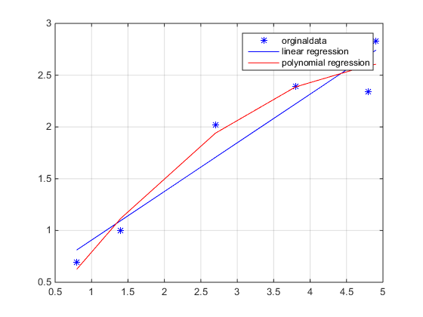

**Figure 2:**

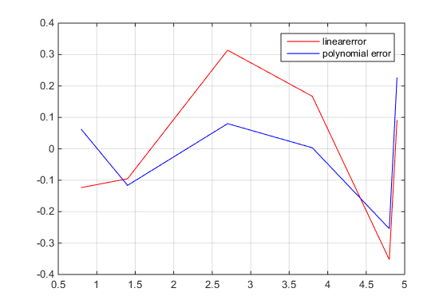

**2. MatlabCode (Practice) :**

clc

clear all

close all

x=input('Enter the value X:');

y=input('Enter the value Y:');

%plot the given points

plot(x,y,'b*')

grid on

hold on

%linear regression

%y = a0+a1*x

n = length(x);

A = [n,sum(x);sum(x),sum(x.*x)];

b=[sum(y);sum(x.*y)];

s=inv(A)*b;

Y=[ones(size(x)) x]*s;

legend

plot(x,Y,'-b')

grid on

hold on

%polynomial regression

%y = a0+a1*x+a2x.^2

n=length(x);

AA = [n, sum(x), sum(x.^2); sum(x),sum(x.^2),sum(x.^3);sum(x.^2),sum(x.^3),sum(x.^4)];

bb=[sum(y);sum(x.*y);sum((x.^2).*y)];

ss=inv(AA)*bb;

yy = [ones(size(x)) x x.^2]*ss;

plot(x,yy,'-r')

grid on

hold on

legend('orginaldata','linear regression','polynomial regression')

%% error estimation

% linear regression

e=y-Y;

figure

plot(x,e,'-r')

grid on

hold on

% polynomial regression

ee=y-yy;

plot(x,ee,'-b')

grid on

hold on

legend('linearerror','polynomial error')

**Command Window :**

Enter the value X:[2;9;4;8;2;5]

Enter the value Y:[9;8;9;7;2;7]

**Figure 3:**

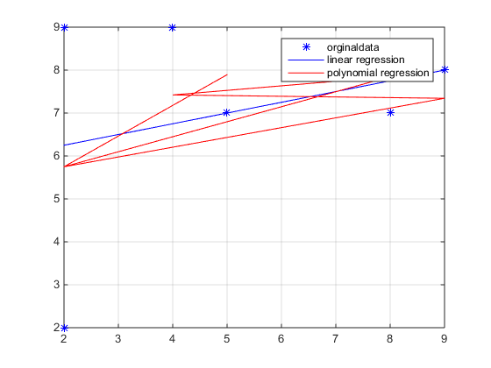

**Figure 4:**

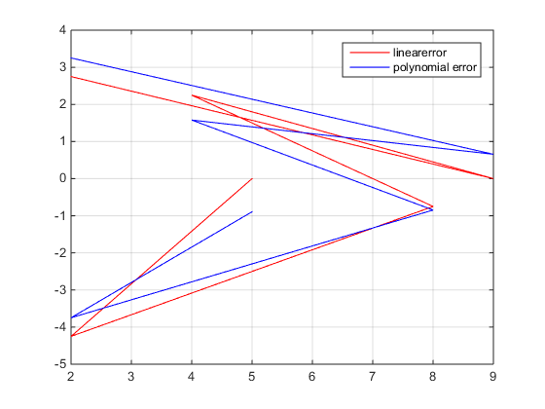

**Discussion:** This experiment name is error minimization using Linear and Polynomial regression. The 1st one program code was given as lab manual and the 2nd program code was done as practice program code. For the both program codes, the value of X and Y has given as a user input. So, there is a function called input. For the 1st program code the value of X and Y was given, so I input those values in the command window but for the 2nd program code which is as practice program code, here the value of X and Y has taken as my wish. After entering the value of X and Y got the desire figures. In figure 1 and figure 3 original data, linear regression, polynomial regression are indicated. In figure 2 and figure 4 linear error and polynomial error are indicated. There are different colors that has used to indicate linear error and polynomial error. Red color is for linear error and blue color is for polynomial error.

This code is easy to perform but need to be attentive while doing these and have to know about the require functions, linear regression and polynomial regression correctly otherwise there will be problem in writing those codes.